Chapter 17, Problem 55.

Obtain the exponential Fourier series expansion of the half-wave rectified sinusoidal current of Fig. 17.82.

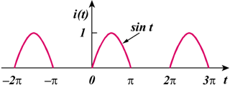

Figure 17.82
For Prob. 17.55.

